**Voxspell User Manual**

elee353, Mike Lee

**Contents**

**Initialisation** 2

**New Quiz Function** 5

**Reward for Distinction** 7

**Review Quiz Function** 10

**View Statistics** 11

**Delete Statistics** 12

# **Initialisation**

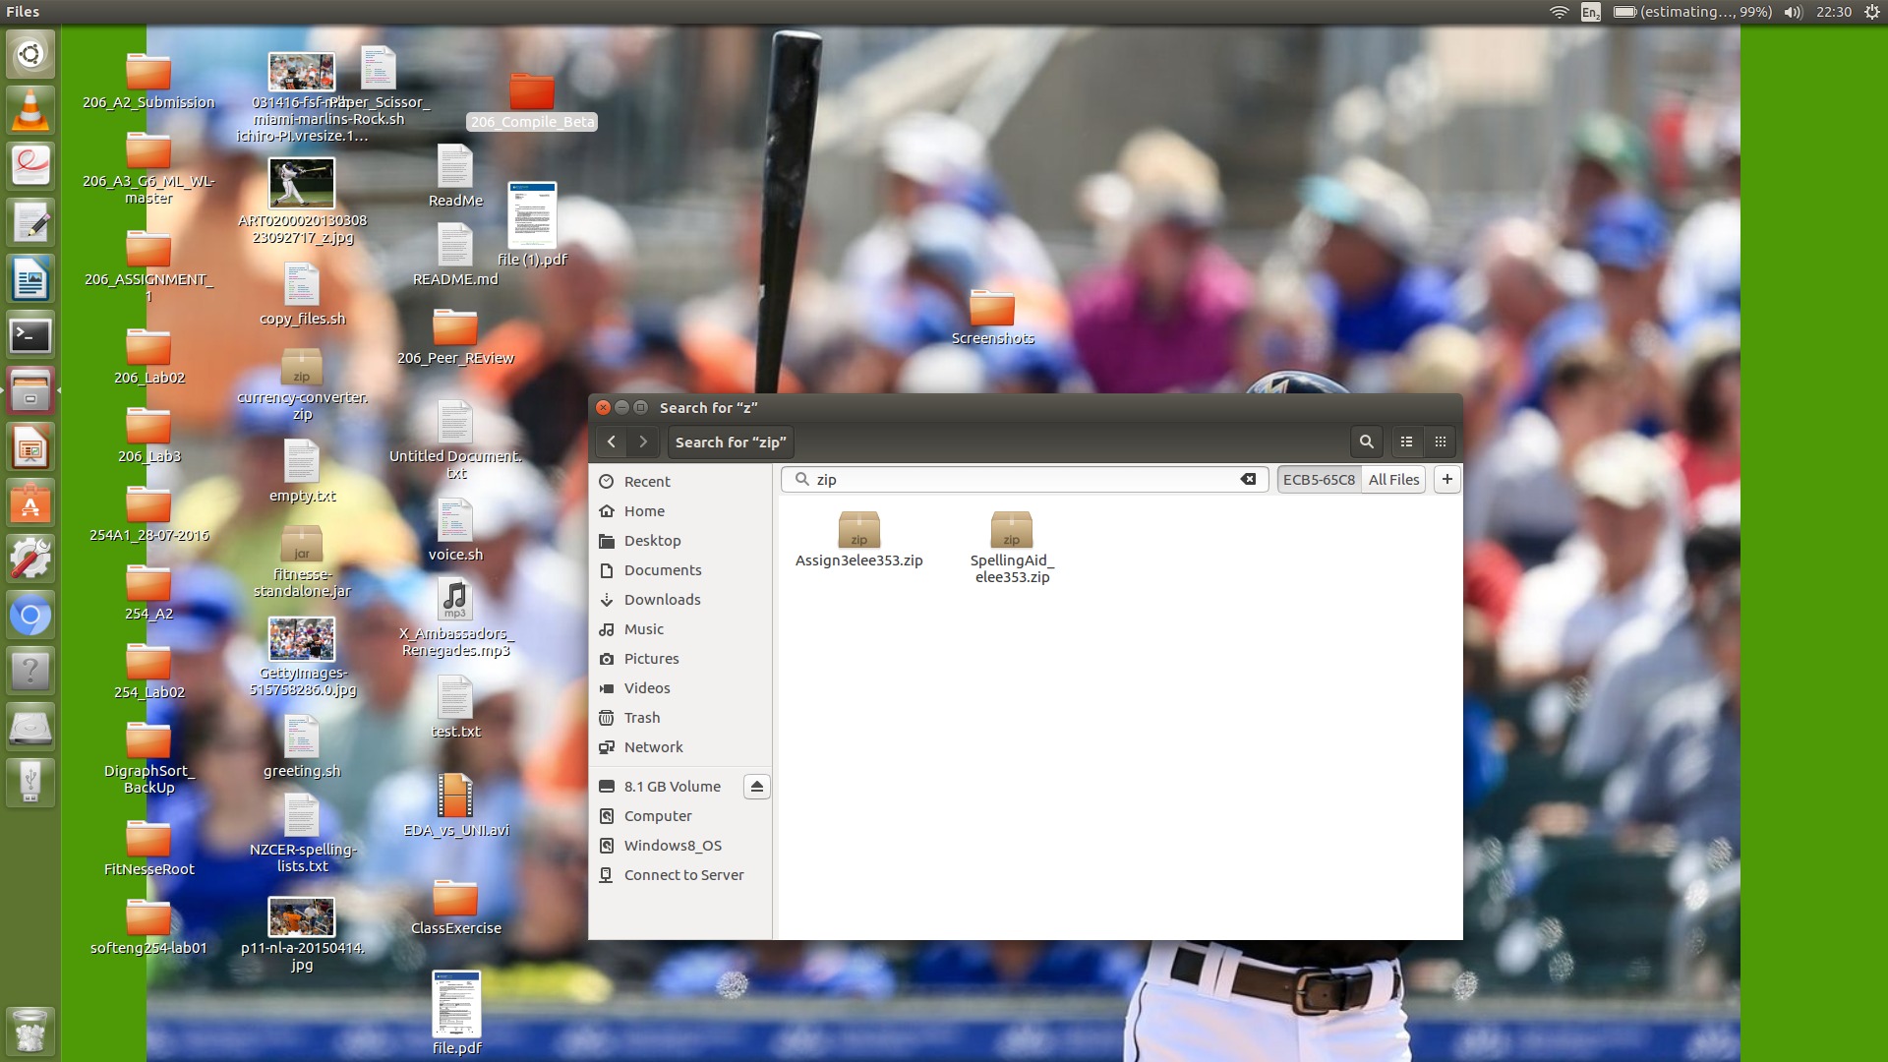

Right click the ‘SpellingAid.zip’ and select ‘Run’ to start.

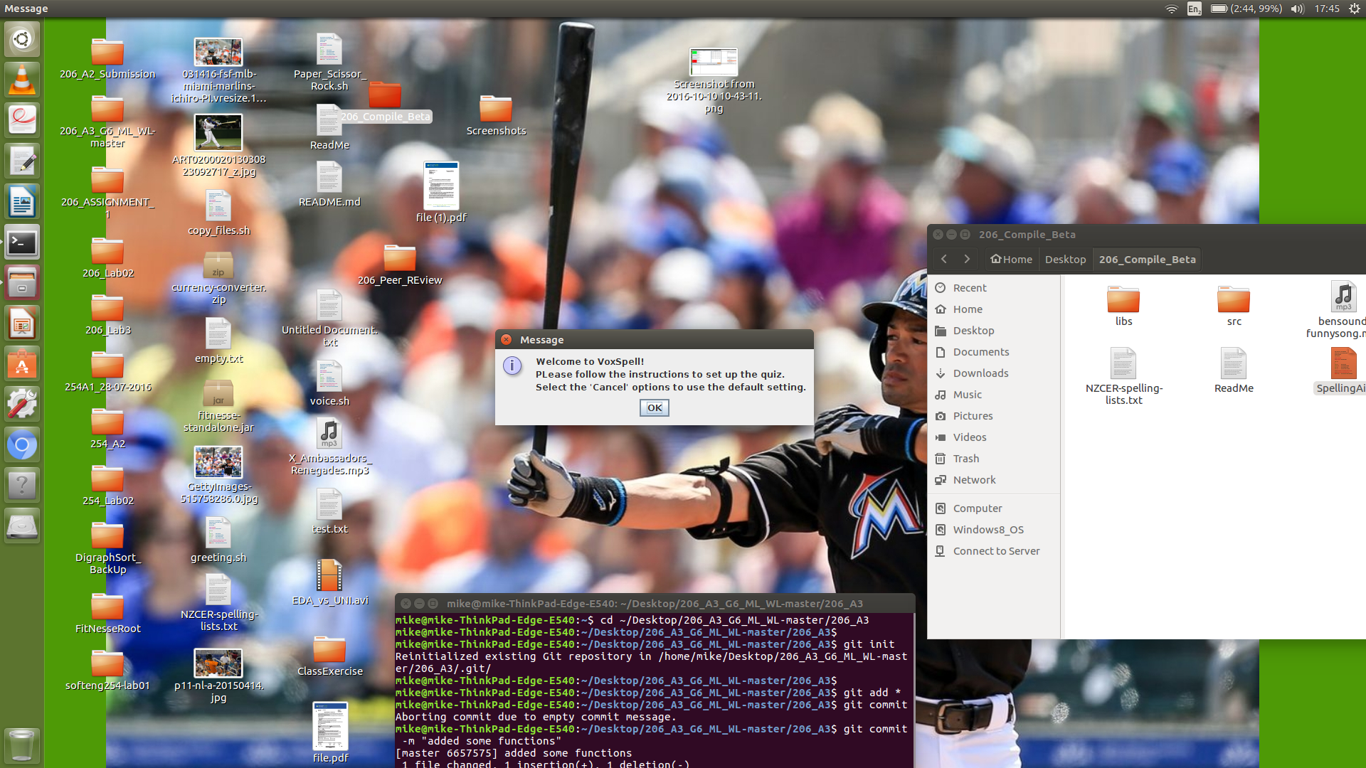

The welcome message will be shown, press ‘OK’ to continue.

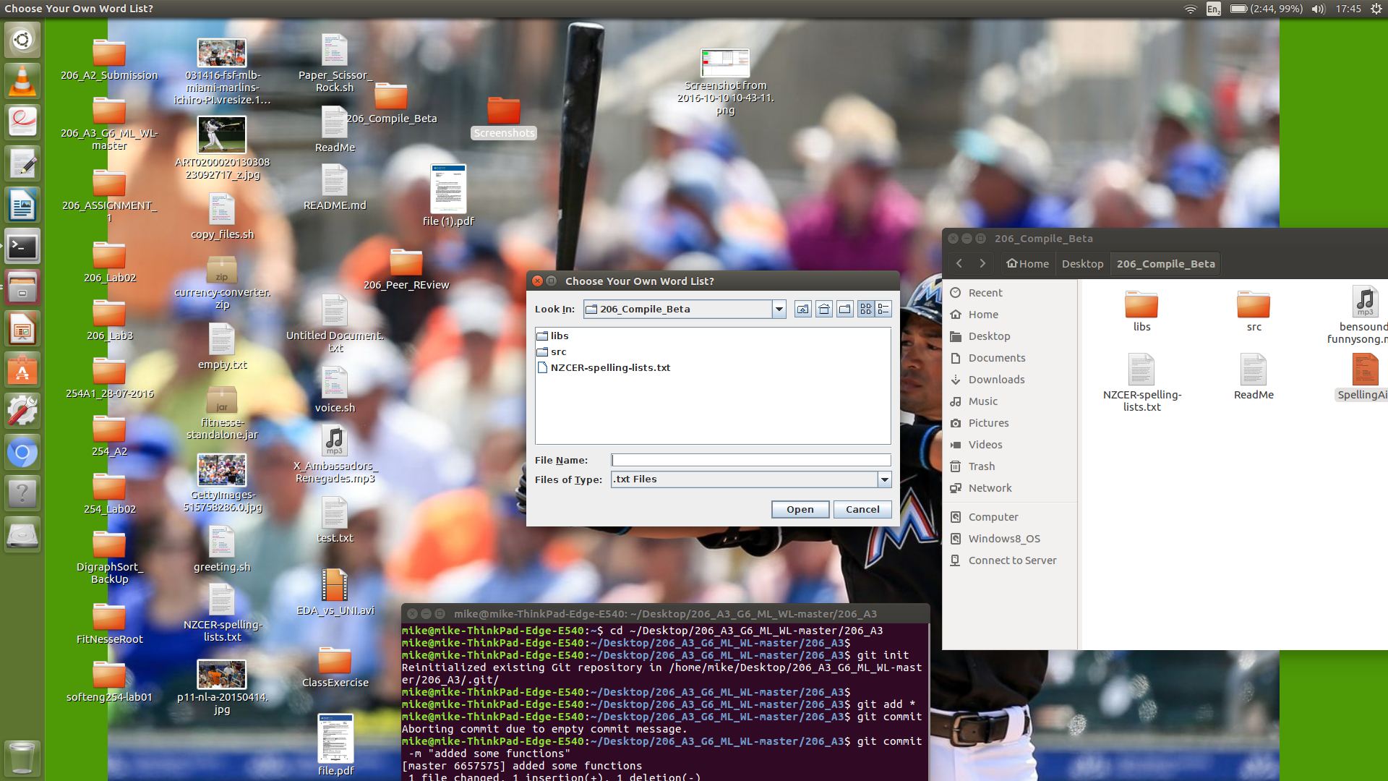

The user can load his or her own word list. The word list must be in the ‘.txt’ format.

Select the ‘Cancel’ option to use the default word list.

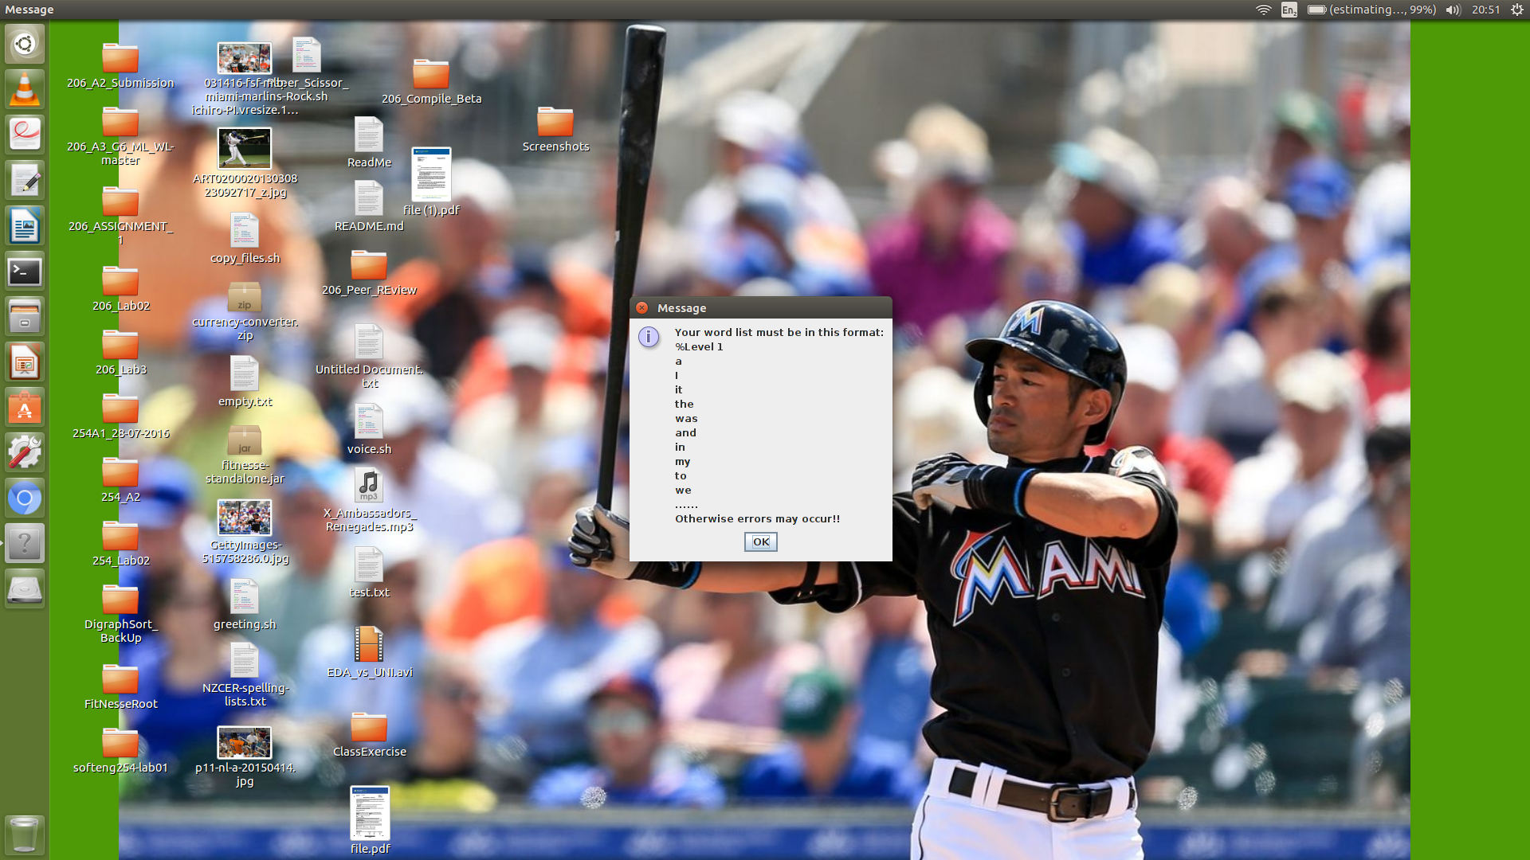

The custom word list must follow the format as shown above. Select ‘OK’ to continue.

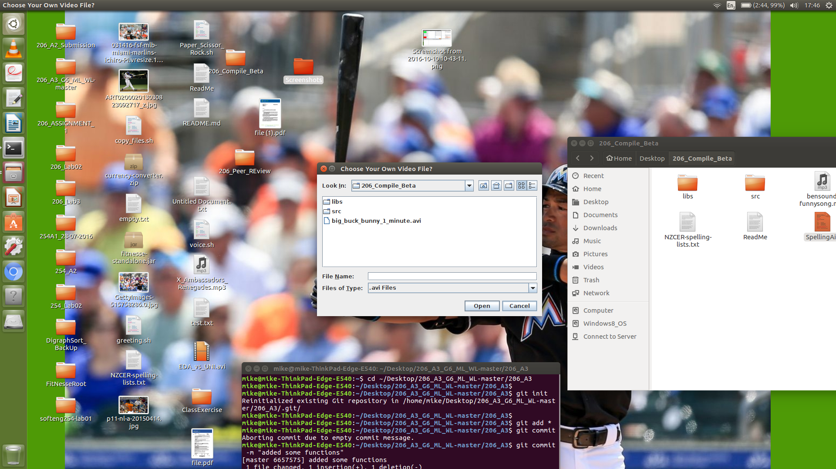

Similarly, the user can load his or her own video file. The video file must be in the ‘.avi’ format.

Select the ‘Cancel’ option to use the default video.

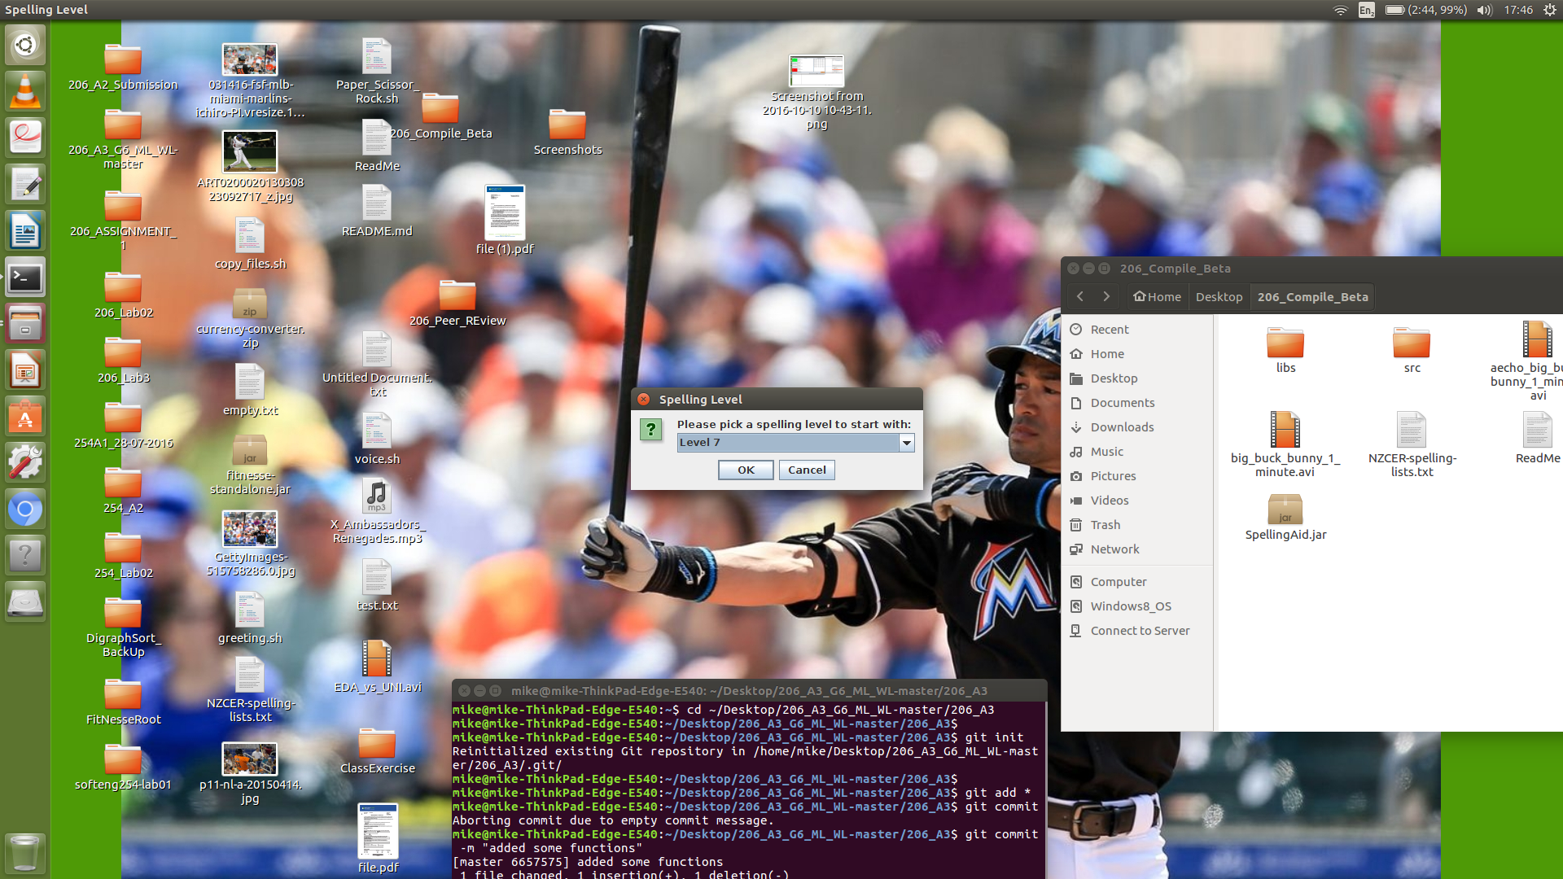

The user must select a level to start with. It may take a few seconds to load everything before the start screen shows up.

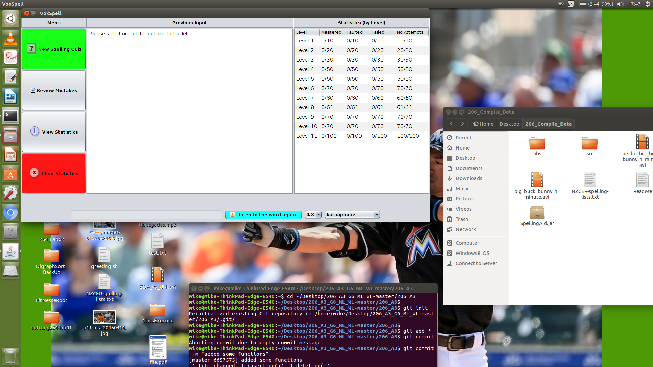

Finally, we can go to the main menu. Select one of the four options on the left to continue.

**Note:**

Please note when loading any files into the program, it is recommended that your make a copy in the current directory and select that specific copy. This can reduce the possibility of errors due to some technical issues in file path detection.

# **New Quiz Function**

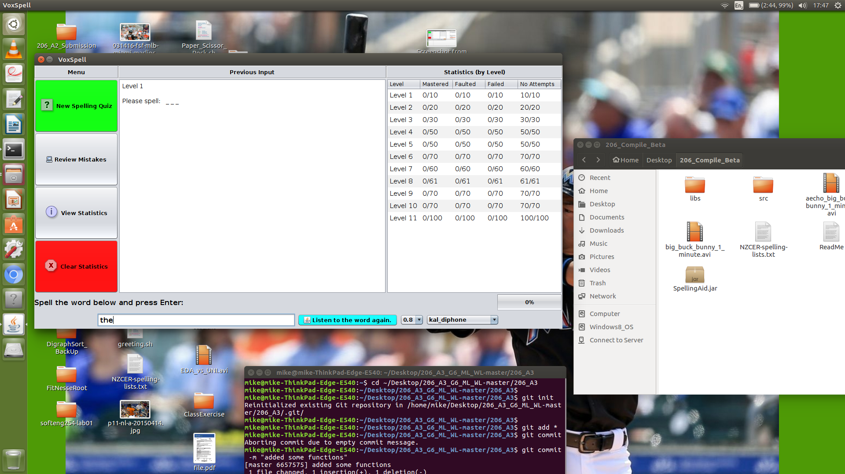

A new quiz will be started after the ‘New Spelling Quiz’ button is pressed.

Basic operations:



1. The user should enter the answer in the text box and press ‘Enter’ to submit.
2. The ‘Listen to the word again’ button allows the user to listener to the current word again.
3. The number on the right is the speaking speed of the voice system. It can be adjusted between 0.8 and 2.2, incrementing by 0.1. The larger the number, the slower the voice system will speak.
4. The drop down box on the right contains the voices or accents available. There can be up to six voice options available.
5. The progress bar on the most right hand side shows the progress of the current quiz. There will be ten words chosen for each quiz.
6. Lastly, the live statistics will be updated in the table on the right.

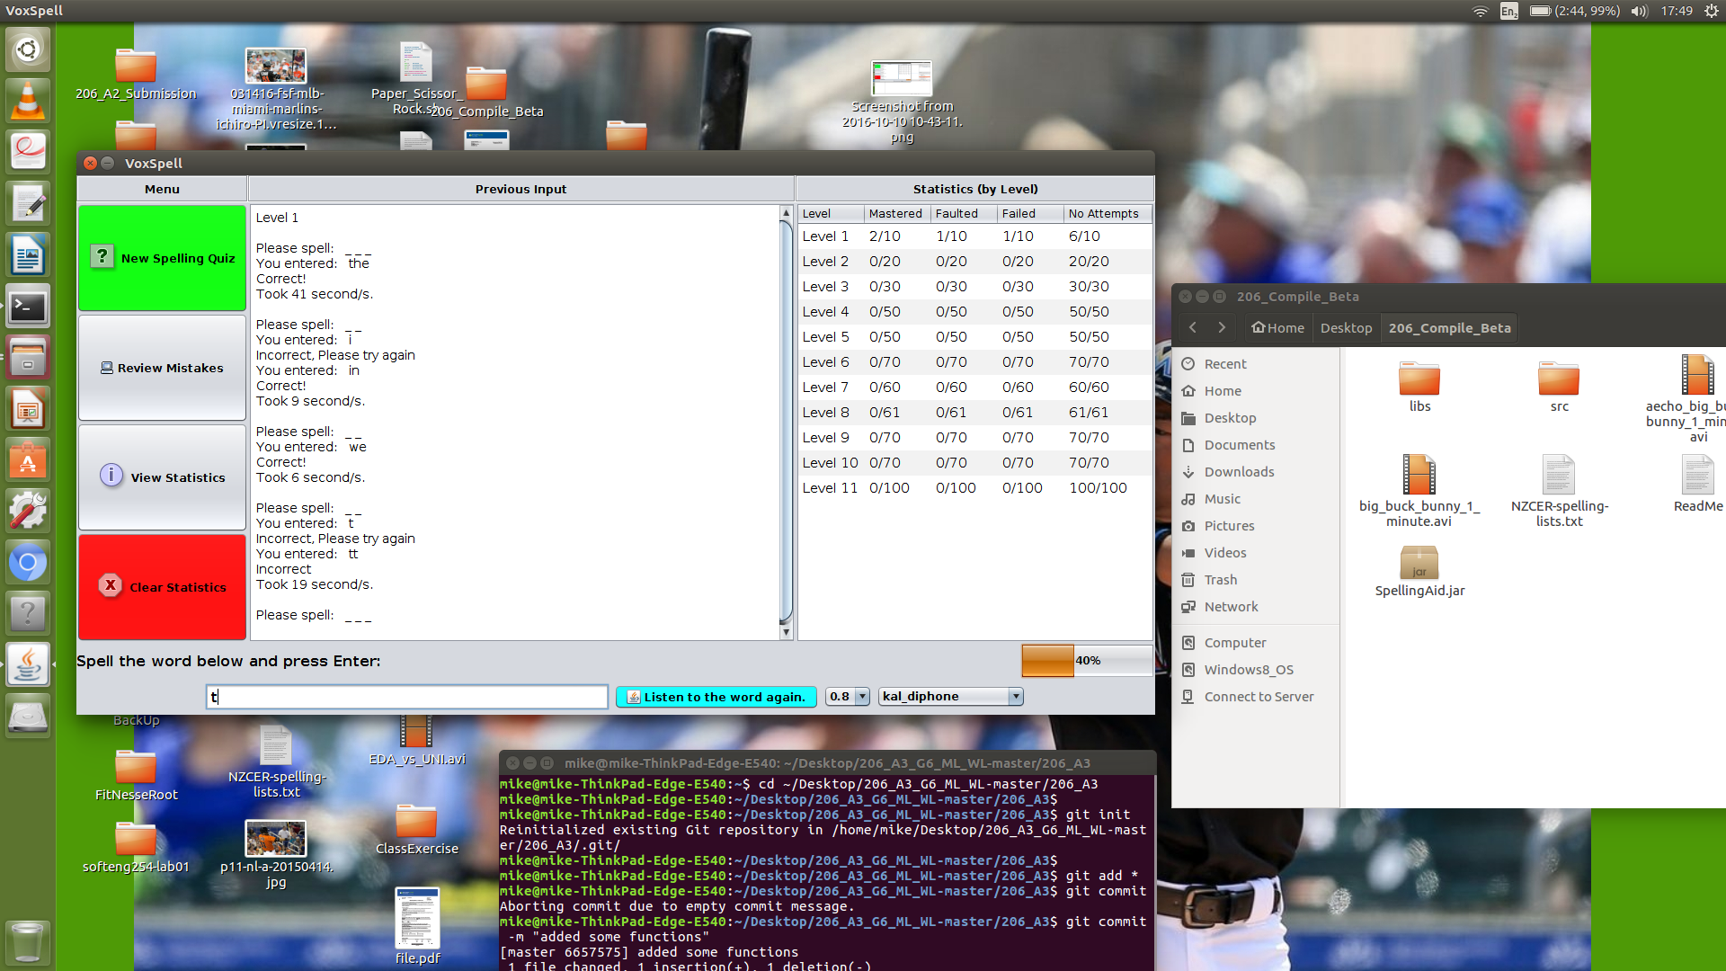

The underscores as shown above indicates the length of the current word.

There are three possible outputs for each word entered in a quiz, they are listed below:

1. Correct: Correct in the first attempt.



2. Faulted: Incorrect in the first attempt, but correct in the second one.



3. Failed: Incorrect in both attempts.



**Note:**

Please note that once a quiz is started, it must be completed before the user can use other functionalities.

# **Reward for Distinction**

A reward option is provided when the user gets nine out of the ten words correct in a quiz.

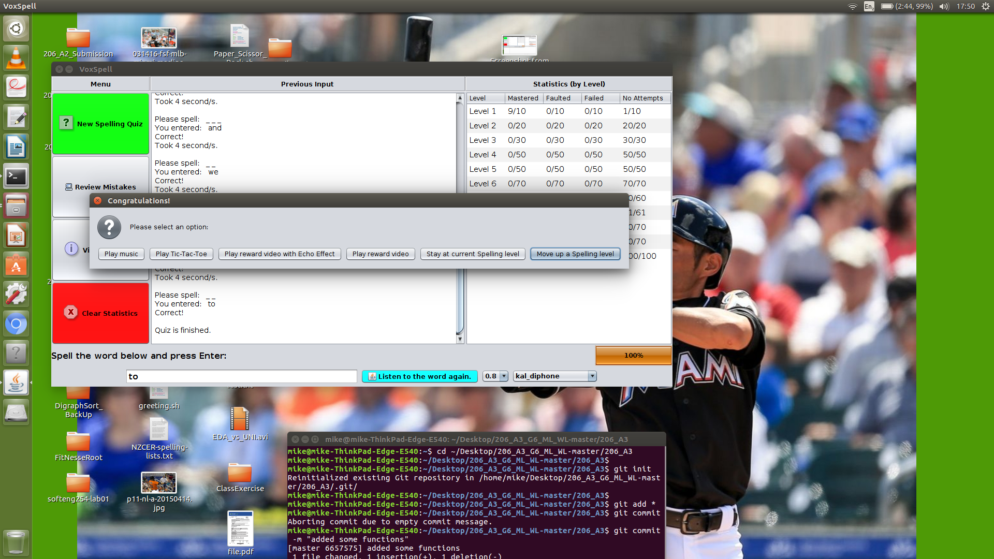

1. Play Music

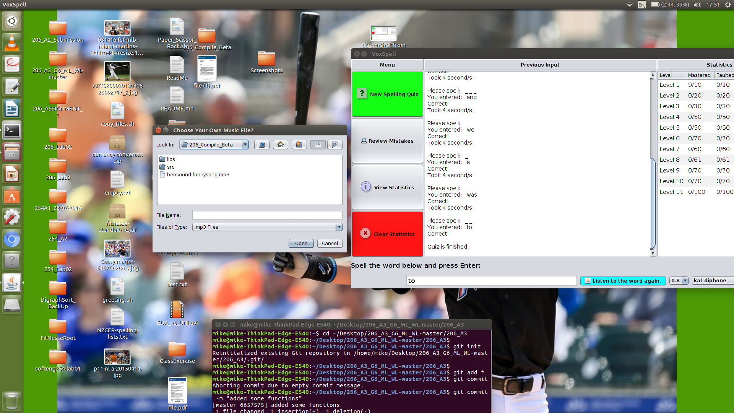

Similarly, the user can load his or her own music file. The music file must be in the ‘.mp3’ format.

Select the ‘Cancel’ option to use the default music.

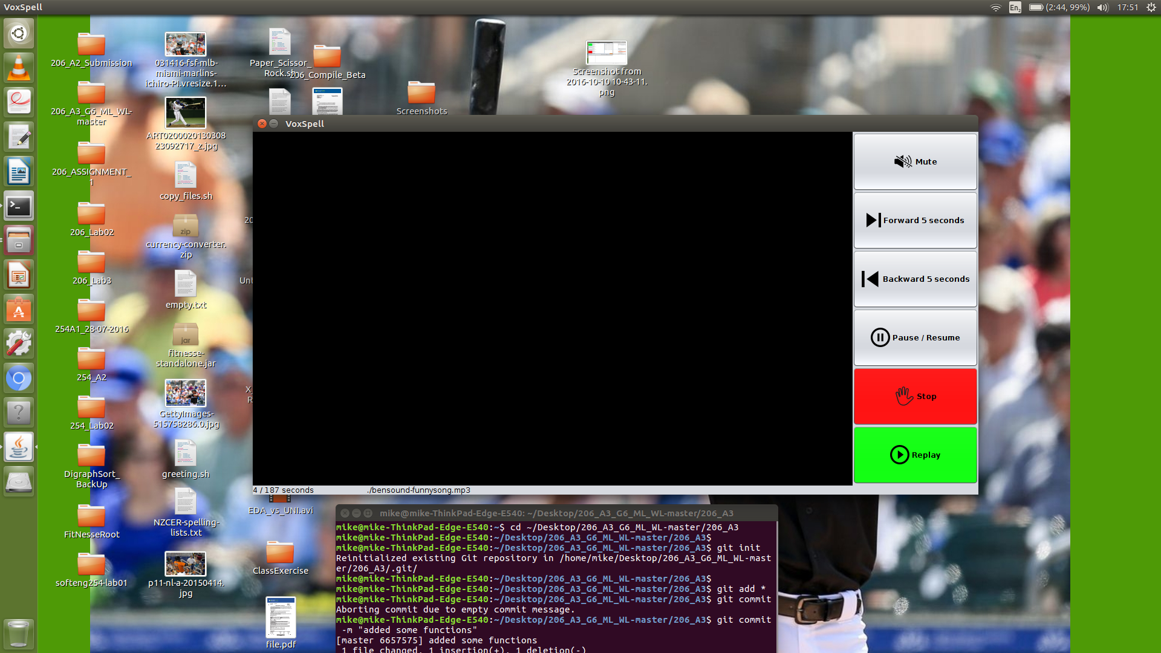

The music player is shown above. The fundamental functionalities provided are mute, forward, backward, pause/resume, stop, and replay.

2. Play Tic-Tac-Toe

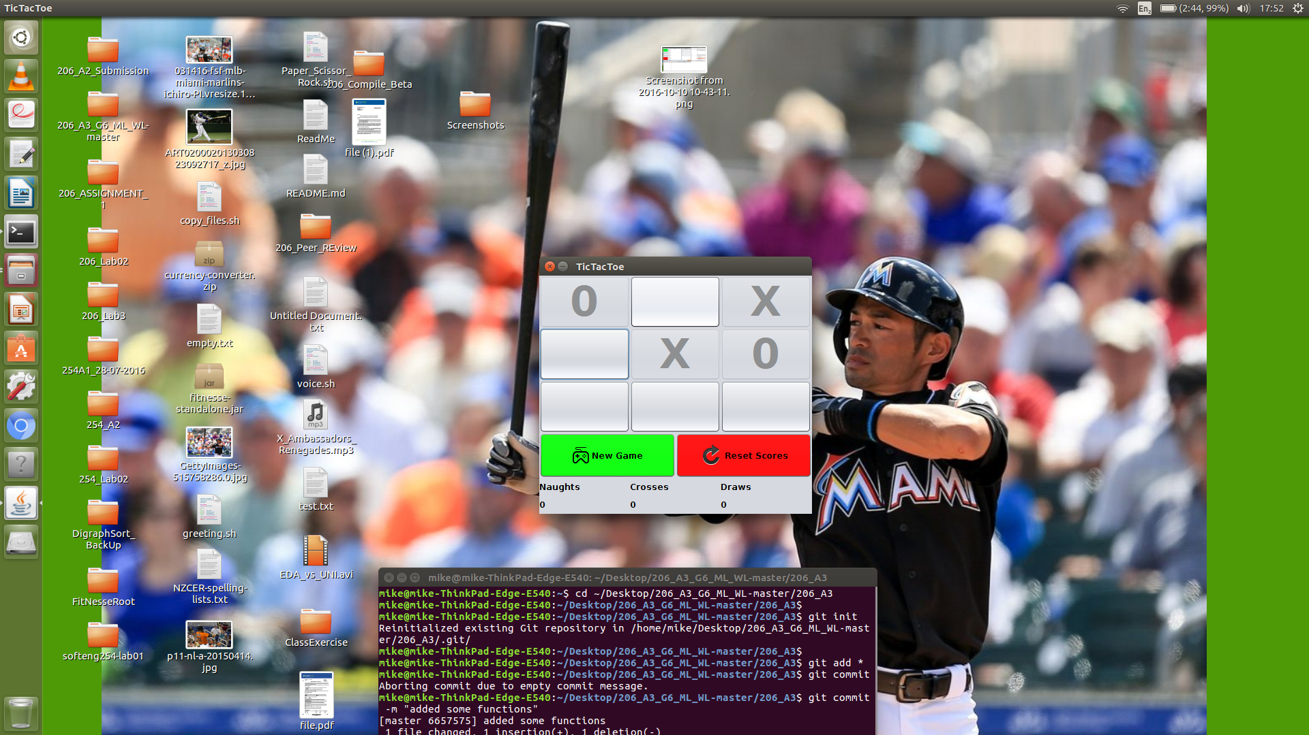

The Tic-Tac-Toe game is a one person game.

Press ‘New Game’ to start a new game. Press ’Reset Scores’ to reset all the scores.

3. Play reward video with echo

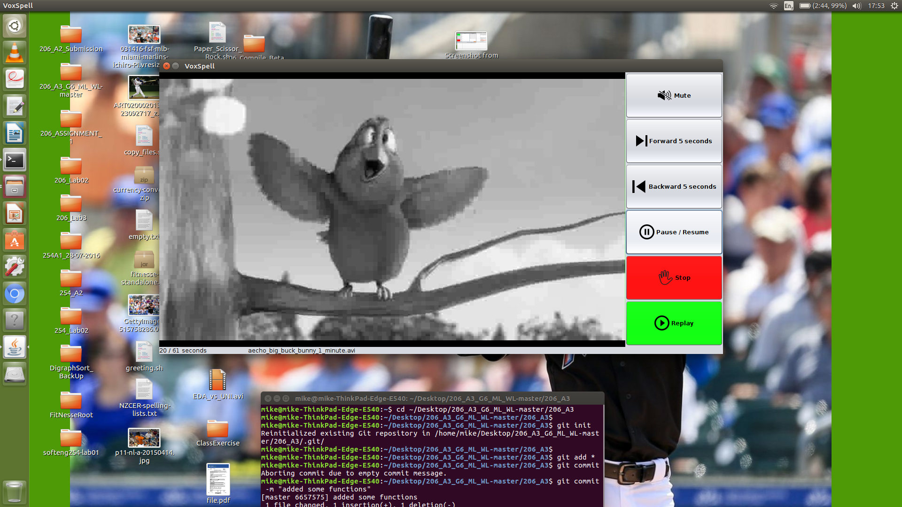

This option plays the video with the echo effect and the video will be processed in black and white.

The media player’s functionalities are the same as the music player.

4. Play reward video

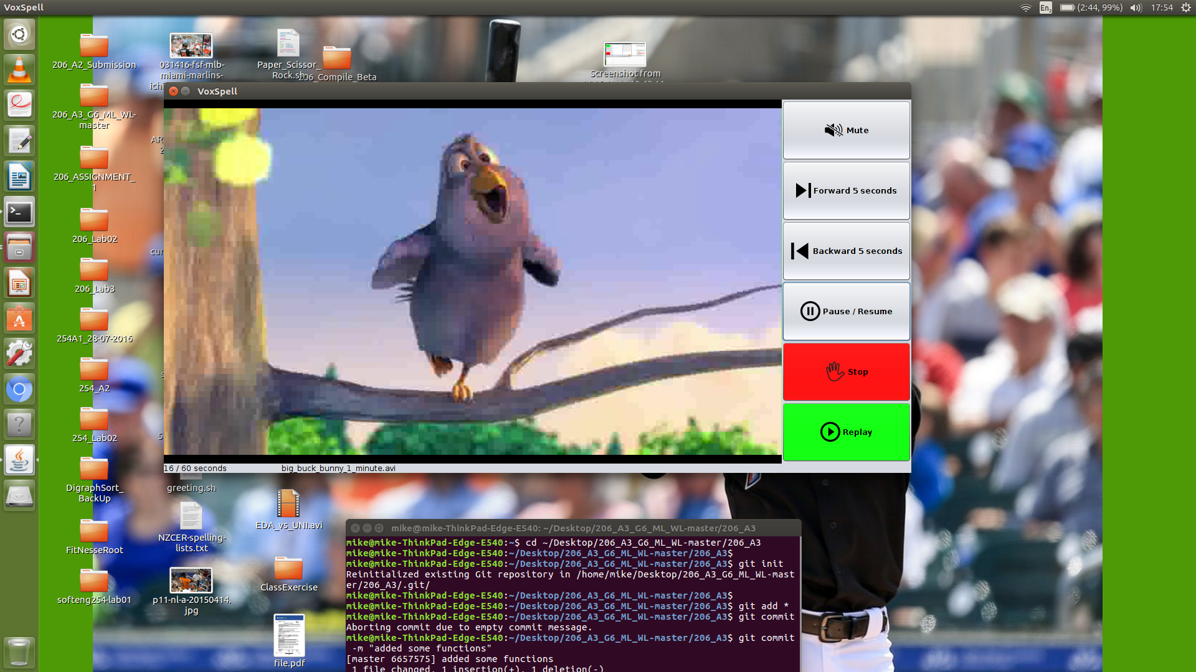

Similarly, this option plays the original video.

The media player’s functionalities are the same as the music player.

5. Stay at current level

This will make the program stay at the current spelling level.

6. Move up a spelling level

This will make the program increment the spelling level by one.

If there is no more levels to increment, the program will stay at the highest level.

# **Review Quiz Function**

A review quiz will be started after the ‘Review Mistakes’ button is pressed.

The review quiz function is similar to the new quiz. Except that the words used will be from the failed words in the current spelling level. In addition, the words used may be less than ten depending on the amount of words failed.

A message as shown below may be given when there does not exist enough failed words to create a review quiz. In this case, there will not be any review quizzes available.

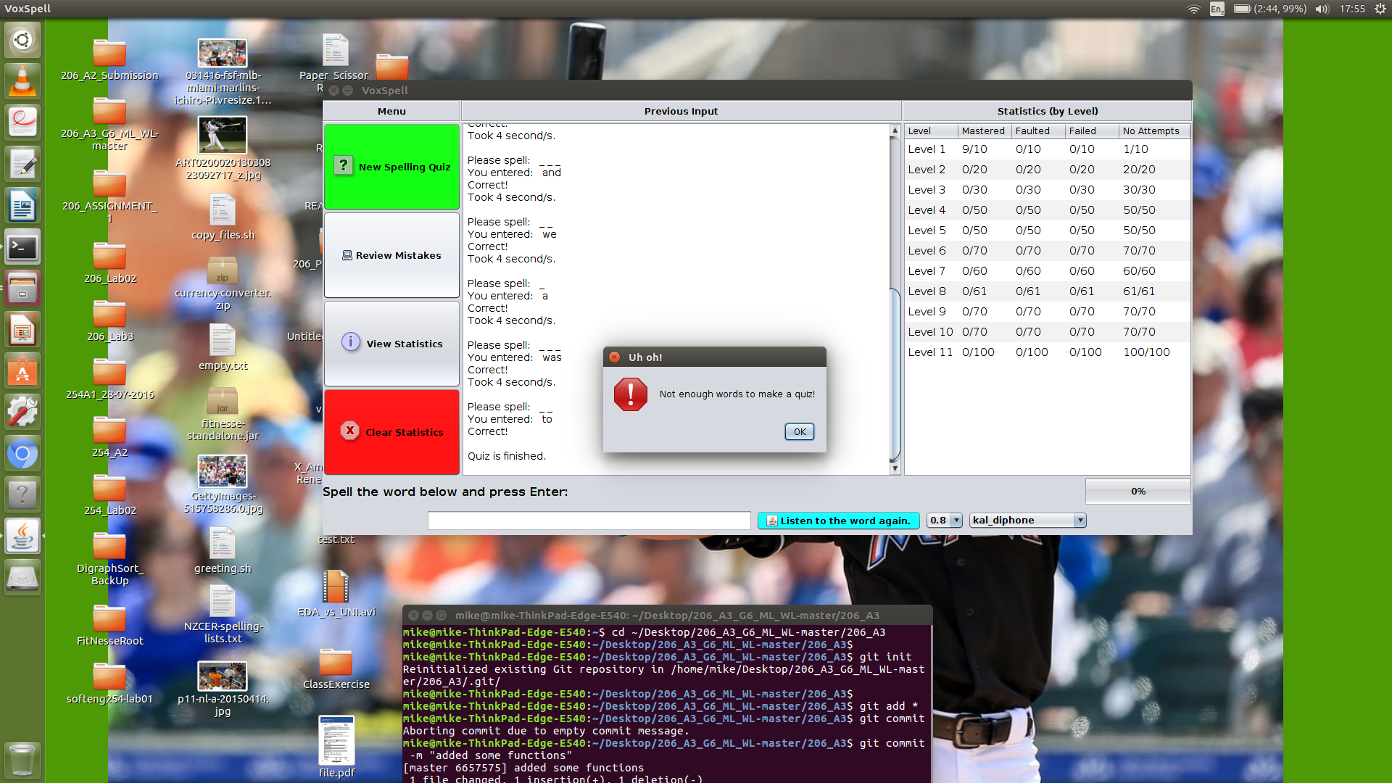

**Note:**

Please note that once a quiz is started, it must be completed before the user can use other functionalities.

# **View Statistics**

The user can view the detailed statistics after pressing the ‘View Statistics’ button. The numbers of times mastered, faulted, and failed for each word will be displayed individually. This may be empty if no words has been attempted yet.

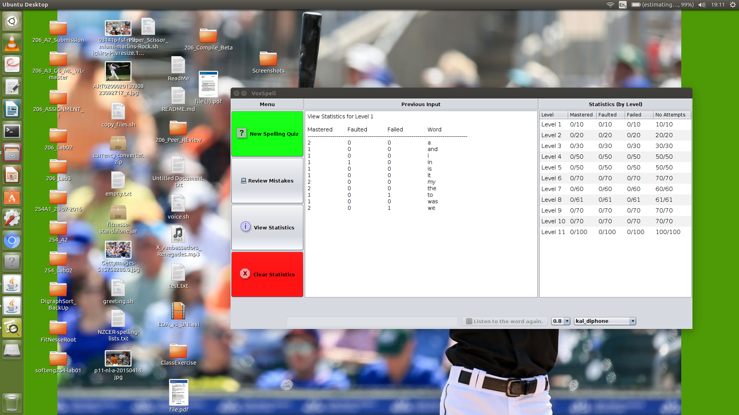

# **Delete Statistics**

The user can delete the statistics after pressing the ‘Clear Statistics’ button.

A confirmation message as illustrated below will show up to double check the action.

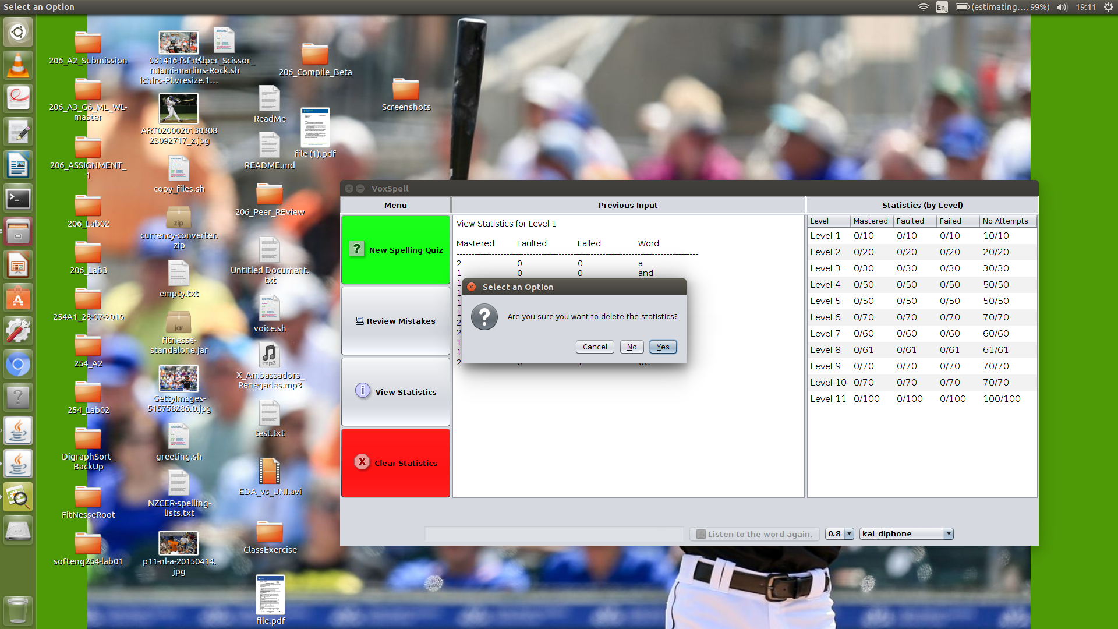

Confirm “Yes” to delete the statistics. The ‘All Statistics Cleared!’ message will be displayed in the middle.

